Repeating History

7/9/2015

# Motivation

Pension fund investment returns tend to be correlated with tax bases so that when returns are really bad, tax bases tend to do poorly, for a variety of reasons. The result is that required contribution increases are particularly difficult for governments to afford. We want to gain insight into how this affects contribution pressures.

The graph below shows that this is a real phenomenon, but that returns and tax revenue hardly move in lockstep. All of the data are on a typical state fiscal year basis (July-June) sine 46 states are on that basis and the preponderance of pension funds also appear to be on that basis. (Thus, real GDP patterns may look different from what you are used to on a calendar year basis.)

The red line is % change in real GDP (BEA); blue line is % change in real state govt taxes (Census); and green line is “synthetic” nominal % returns for typical pension funds (sorry, did not have time to do real), based on my analysis of Flow of Funds data (asset allocation) and data on returns of several asset classes from several sources (more on that later).

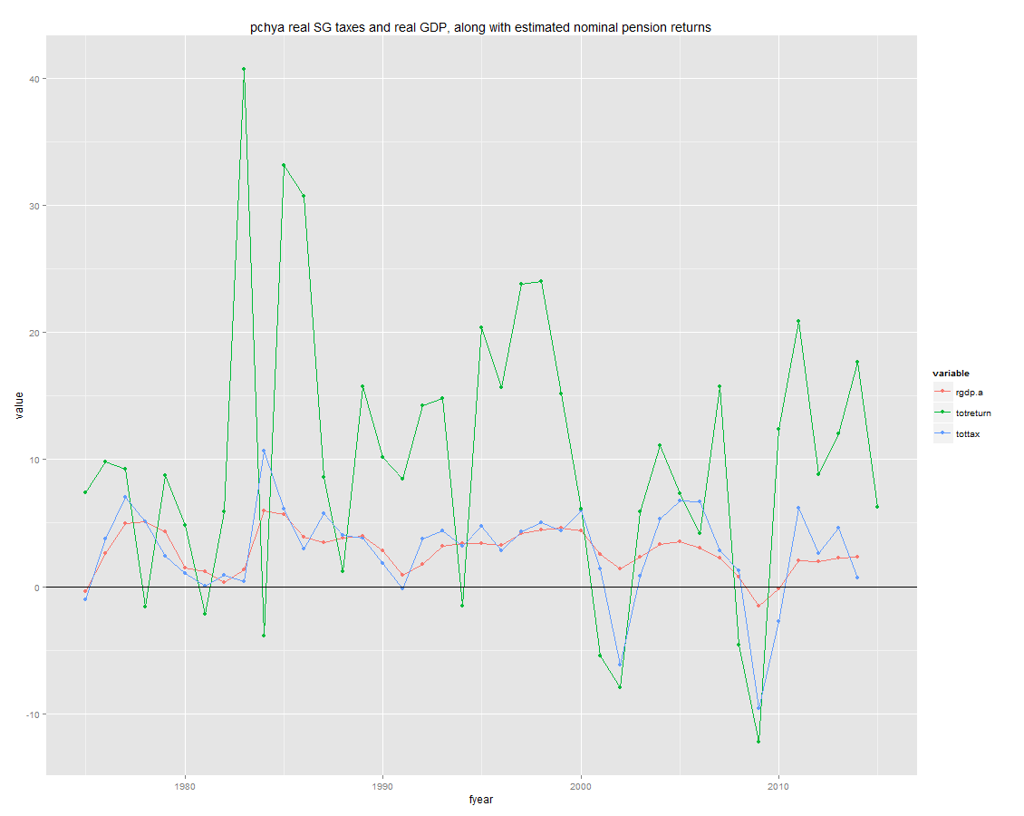

The lessons of the graph are:

* Real taxes are more volatile than real GDP, and have become more so in the last two recessions (reasons for this are well known).
* In the last 2 recessions (2001 and 2007) returns fell sharply as taxes fell sharply, and rose sharply as taxes rose sharply.
* While there may have been a relationship between returns and taxes before the last 2 recessions, it is not obvious from this graph. In principle, we know that declines in real GDP generally will drive taxes down, and we can see that in several prior recessions on the graph. They also probably – many people believe – drive real returns down, although that is not obvious, perhaps because I only have nominal returns here (inflation was higher and falling in the 1980s) or because of asset class mixes since bonds can deliver pretty strong returns when interest rates are falling. But in any event, it’s hard to know what to make of the period before 2000.

If the relationship between returns and tax bases were simple, we could model it. But it’s not, and we may never understand it well enough to model it. Obviously there are other variables and factors at work.

But we can ask what would happen if we had a repeat of one or two historical episodes, where GDP, taxes, and returns were correlated. The goal is not to predict, but to understand a scenario.

# Approach

The basic idea is to construct one or two episodes that are very much like what we observed in the past. For each episode, we would want a sequence of years, with the following information:

* Growth in real GDP
* Growth in real tax bases
* Nominal and real investment returns

The goal would be to run a single deterministic run, perhaps with a few years of smooth results, and then entering the stress and recovery periods, with returns similar to past stressful period, and taxes also similar. We’d then examine how required contributions change, and how large that is relative to the tax base.

We could simply use historical data for the last 2 recessions, but for a few complications:

* Taxes:
  + There are no data on tax “bases”. There are data on tax revenue, but those are a little suspect because they include tax policy changes (e.g., tax increases in response to recession). Thus, we might want to construct a cleaner tax base.
  + Different taxes behave differently in recessions, and states have different tax structures, so even if they all had the same economies they would have different results. We can’t create a scenario for each state, but we could have information on different major taxes, and combine them in prototypical ways. (Note: I focus here only on state govts. I ignore local governments, which means I ignore the property tax, which tends to be relatively stable. That is for another day.)
* Returns:
  + The PPD data only have returns back to 2001. We’d like to have at least a few years before that, and much longer would be nice.